Steps

1. Open Connection to file (specified read / write) using **fopen()**
2. Perform read / write
3. Close connection

fopen() options

* r Read only, file pointer at the beginning of the file
* a Writing only, places file pointer at the end of the file
* a+ Reading and writing, places file pointer at the end of the file
* w Writing only: deletes file content, or will create a new file
* w+ Reading and Writing, pointer at the begining

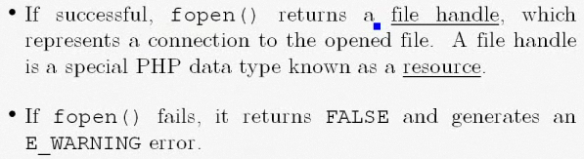



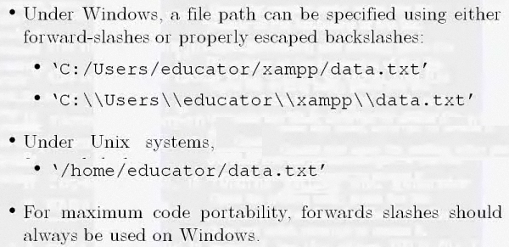

**OPEN FILE FOR READING**

USING RELATIVE PATH



OR USING ABSOLUTE PATH

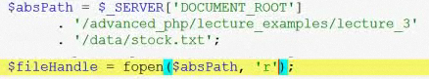

CHECKING IF THE FILE WAS OPEN

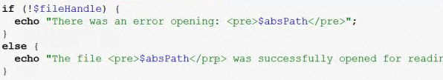

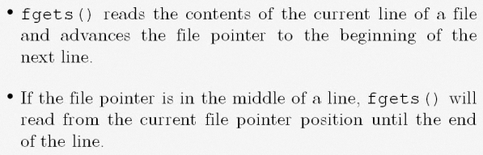

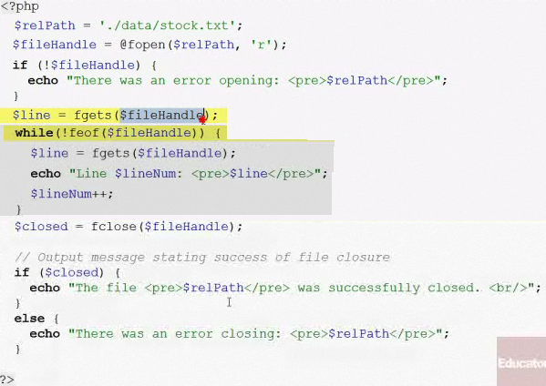

IF THE FILE IS



IF WE GO EACH LINE WITH

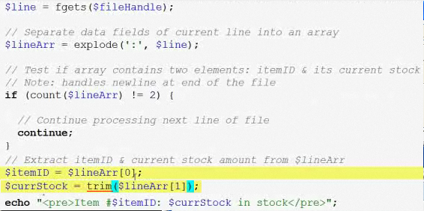

THE OUTPUT WILL BE

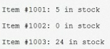

IF WE TAKE OUT ‘TRIM’ IT WILL LOOK

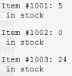



Writing a new line

